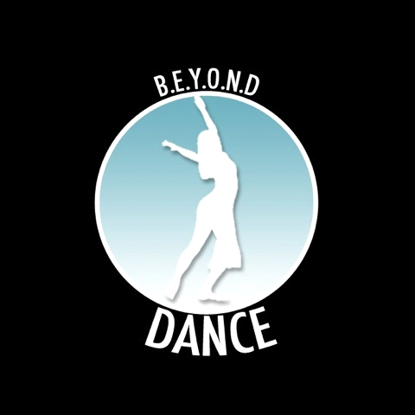
BEYOND DANCE CO.
https://beyonddanceco.weebly.com
(267)438-3650
COMPANY AUDITIONS
Vision and Mission of BDC: The vision of Beyond Dance Co. is to promote unity and encourage excellence to prevail in the lives of young adults through the expression of dance. We believe that it is necessary to commit ourselves to going beyond expectations to unify and strengthen one another through any and all adversities to bring out the most positive and beneficial result so that success is the overall outcome. This is not just the vision for those in our company but the mission for us to spread this sense of empowerment and excellence through unity among the community as well. One of the main objectives of BDC is to use dance as a means to immerse ourselves in many environments and show that dancers are not just moving beings on a stage but individuals who are concerned about the interests of the community as well. This is done through raising money for local charities and engaging in community service projects.
BDC thrives on its diversity not only in the members but also in style, as we showcase multiple dance styles twice a year in our annual spring and winter performances including modern, ballet, hip hop, lyrical and more. We have presented our work in various performance showcases in the Philadelphia region such as the 2015 Koresh Artist Showcase, 2015 & 2016 IDA Blackbox showcase, the 2016 Dance Diversity Tour, the 2017 Dance Diversity Tour, Project Moshen's Artistry Unfolded (2016), 2015 & 2016 ETC Performance Series, 2016 10th annual NYC Dance Festival and Parade as well as on the Main Stage of the 2017 11th Annual NYC Dance Festival and Parade.

DATE: Sunday, August 25th, 2019
TIME: 2:15pm-4:15pm
LOCATION: 954 Dance Movement Collective
954 N. 8th street
Philadelphia, PA 19123
INFORMATION:
We are looking for dancers (female and male) who have a background in hip hop, modern and/or African/interpretive. You can be trained in other areas of dance as well.
Your attire should be comfortable for this audition. You can wear tights, shorts, short sleeve or sleeveless t-shirts. No specific footwear is required, as you will be dancing either barefoot or you can wear socks.
The registration time is from 2:15PM-2:30PM. Those interested in auditioning can come at that time to give their audition registration form. You can also email the form ahead of time as well to beyonddancecophila@gmail.com. The audition will be promptly at 2:30PM. PLEASE BE ON TIME! If you have a headshot and dance resume, please bring that as well. Please prepare a 1 minute minimum and 2-minute maximum solo dance piece of your choice. In addition, dance company applicants will learn 2 short pieces from BDC instructors to be used in addition for audition evaluation.
All audition applicants will be notified within 24-48 hours of acceptance into BDC.
Audition Applicant Information:
NAME:
ADDRESS:
PHONE NUMBER:
EMAIL ADDRESS:
BIRTHDATE:
AGE:
DANCE EXPERIENCE:

INTERESTED IN (Check One): Dancer ____ Choreographer _______

WHY DO YOU FEEL YOU WOULD BE A GOOD ADDITION TO BEYOND DANCE?

Please attach your headshot and dance resume if applicable.

